ASSIGNMENT 3 REPORT
University of Central Punjab
Faculty of Information Technology and Computer Science
Course Title: Software Construction & Development
Course Code: SESD3242
Project: Library Book Issue System with Exception Handling
Student Information
Name: Aleena Asif
ID: L1F23BSSE0111
Contribution: GUI Design, Validation, GitHub Integration, Documentation
Name: Muzaffar Ali
ID: L1F23BSSE0395
Contribution: Backend Logic, Testing, GitHub Integration

Introduction
This assignment demonstrates the development of a Library Book Issue System using Java Swing. The system allows students to issue books through a graphical user interface while applying exception handling concepts in Java.
Technologies Used
Java
Java Swing
GitHub
Git Bash
JOptionPane
Eclipse IDE
GUI Components Used
JFrame
JPanel
JLabel
JTextField
JTextArea
JComboBox
JRadioButton
ButtonGroup
JButton
JOptionPane
Functionalities Implemented
• Student information input
• Dynamic category and book selection
• Book edition selection
• Remarks section
• Issue Book functionality
• Reset and Exit buttons
• Validation and exception handling
Implemented Exceptions
1. EmptyFieldException
2. InvalidRollNumberException
3. InvalidDateException
4. NullSelectionException
5. NumberFormatException
6. General Exception Handling
7. Finally block implementation
Exception Handling Concepts
The project uses try-catch blocks, throw keyword, custom exceptions, and finally block to handle runtime errors and validations.
Working Flow
1. User enters student details.
2. User selects category and book.
3. User selects edition.
4. Validation is performed.
5. Exceptions are handled if errors occur.
6. Successful issue confirmation is displayed.
GitHub Repository Link
Software-Construction-Development

Screenshots
Insert screenshots of:
• Main GUI
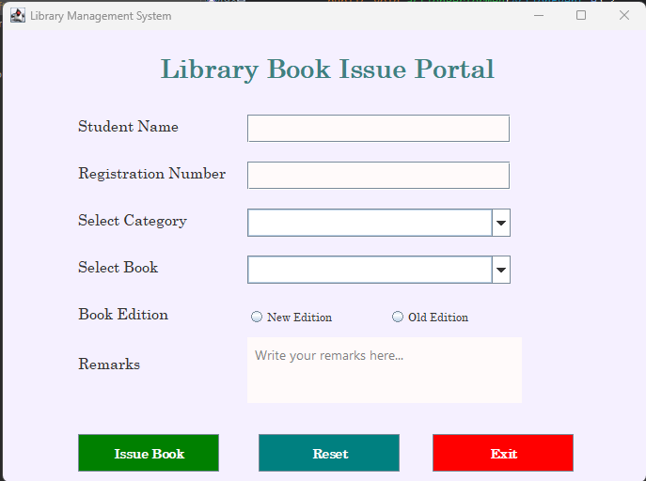
Exception handling messages
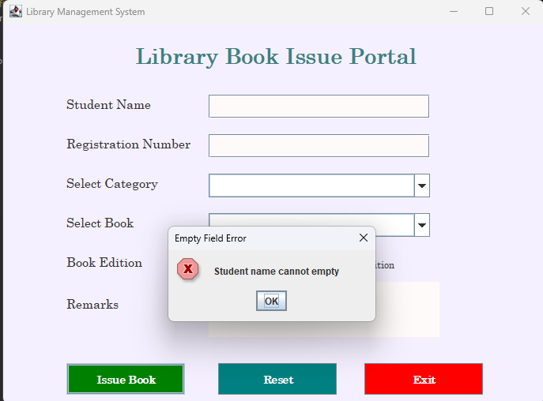
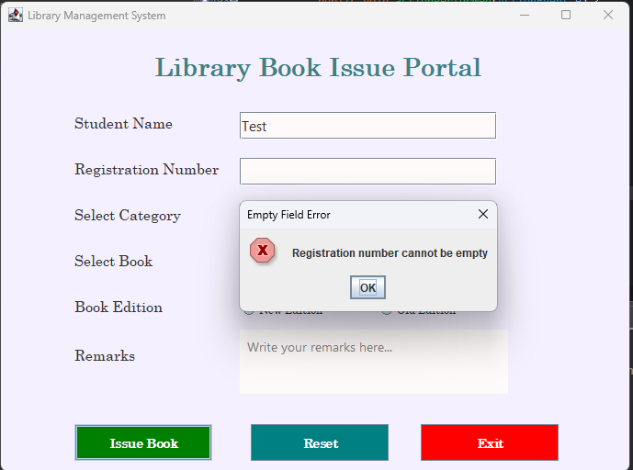
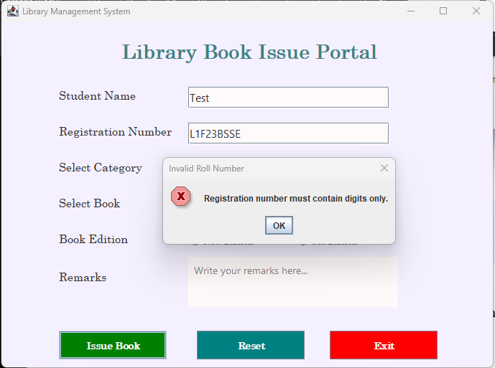
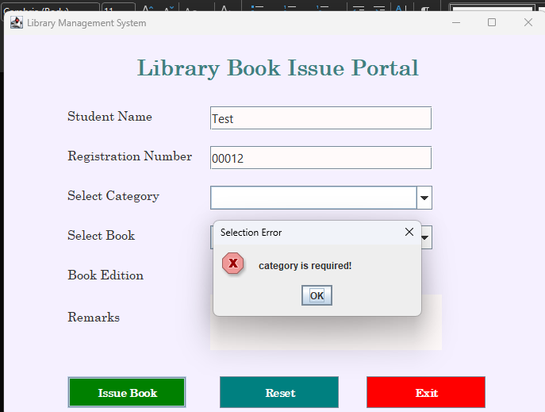
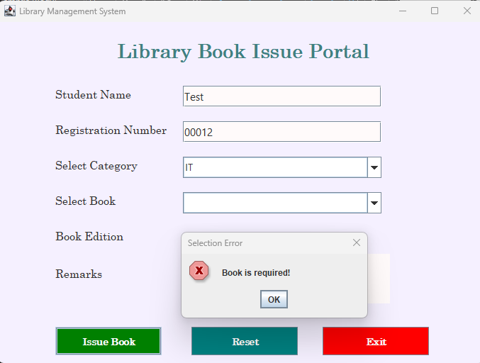
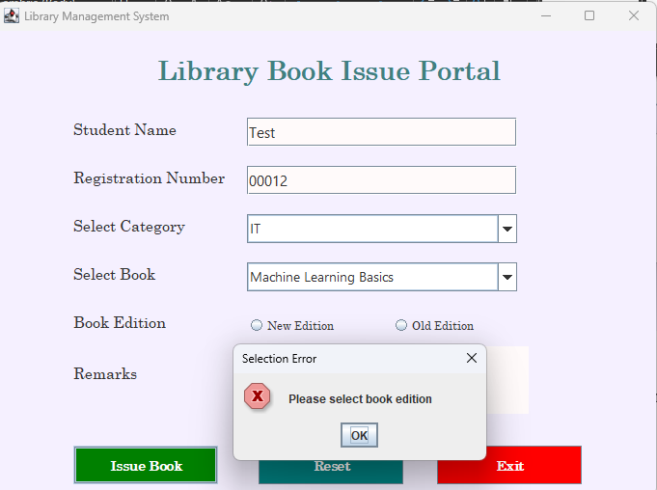
Successful issue confirmation
